

Assignment # 1

Submitted to: Ma’am Dr. Maria Andaleeb

Course code: CT-599 Speech Processing

From: Mirza Ahsan Baig

Roll no: DS-074/2020-2021

**OBJECTIVE:**

Performing speech analysis to find out characteristics, pitch, spectrum and different characteristics using PARAAT software on mentioned below audience.

1. 5 years old boy singing “Dil Dil Pakistan, Jan Jan Pakistan” with Passion.
2. Adult male singing Pakistani Anthem with calmness.
3. Women greeting “Assalam u Alaikum”.
4. Angry man complaining regarding water and electricity issues.

**INDEX:**

|  |  |
| --- | --- |
| **Sr #** | **Analysis Type:** |
| 1 | Formants of Voice |
| 2 | Intensity of Voice |
| 3 | Pitch of Voice |
| 4 | Power Cepstrum Analysis |
| 5 | Excitation of voice |
| 6 | MFCC of voice |
| 7 | Spectrum Analysis |
| 8 | Spectrum Tier Peak |
| 9 | LPC Gain of Voice |
| 10 | LPC Poles of Voice |
| 11 | Cochleagram Analysis of Voice |
| 12 | Manipulation of Voice |
| 13 | Cepstrogram |
| 14 | Harmonicity |
| 15 | Voice complete information |
| 16 | Auto Correlation |
| 17 | Spectrogram |
| 18 | Outer and inner view port of voice |
| 19 | Comparison between all audience |

**Analysis on 5 years old boy singing “Dil Dil Pakistan, Jan Jan Pakistan” with Passion:**

**Formant of Voice:**

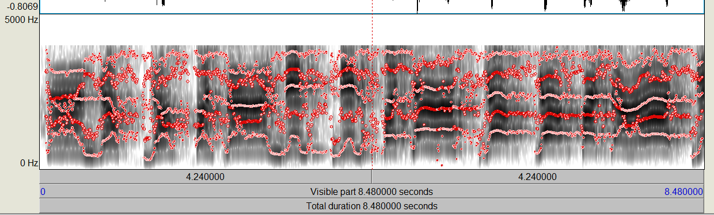

**Intensity of Voice:**

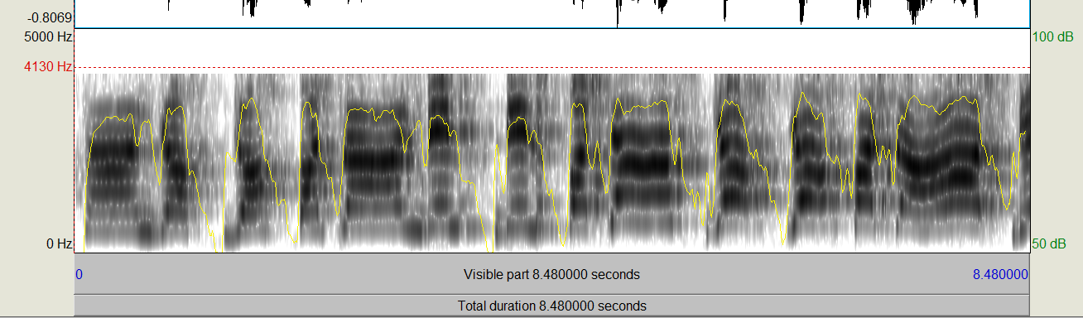

**Pitch of Voice:**

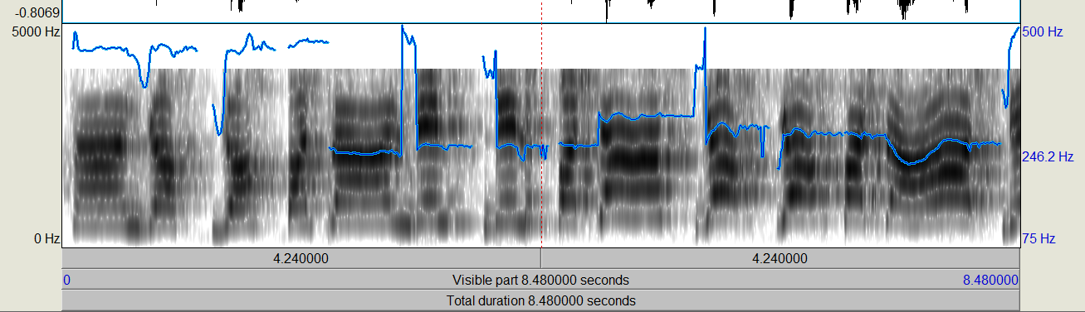

**Power Cepstrum Analysis:**

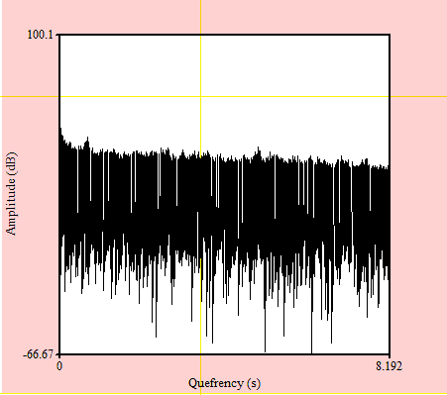

**Excitation of voice:**

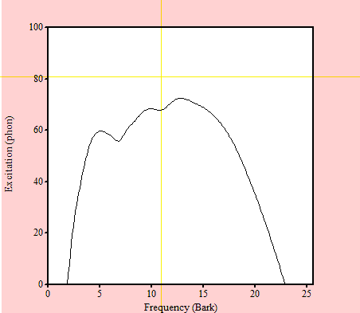

**MFCC of Voice:**

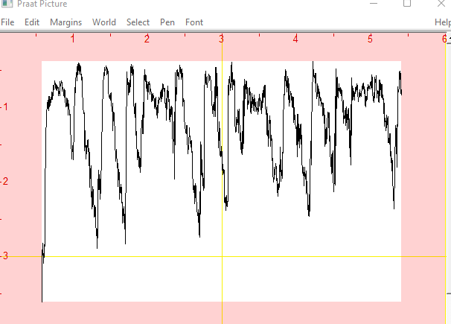

**Spectrum Analysis:**

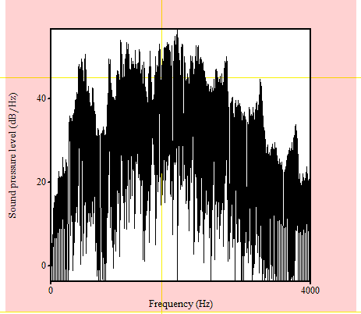

**Spectrum Tier Peak:**

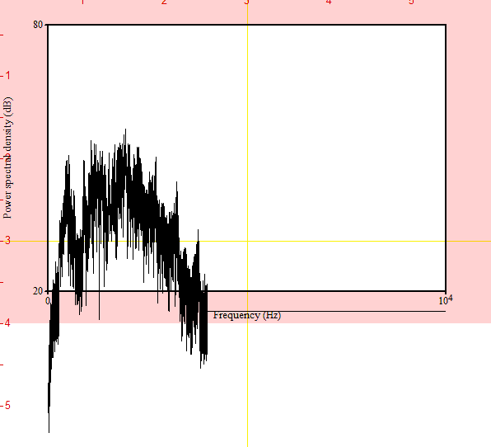

**LPC Gain of Voice:**

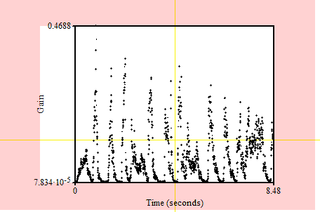

**LPC Poles of Voice:**

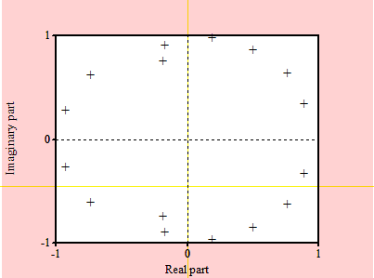

**Cochleagram Analysis of Voice:**

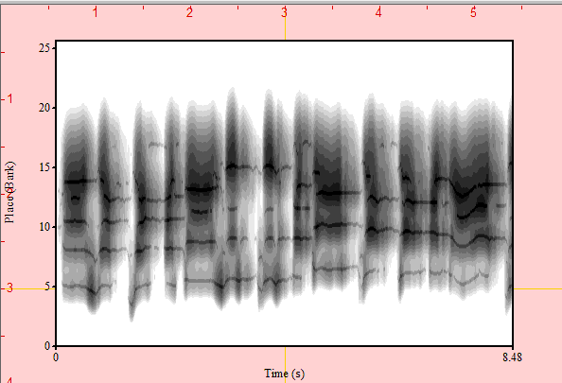

**Manipulation of Voice:**

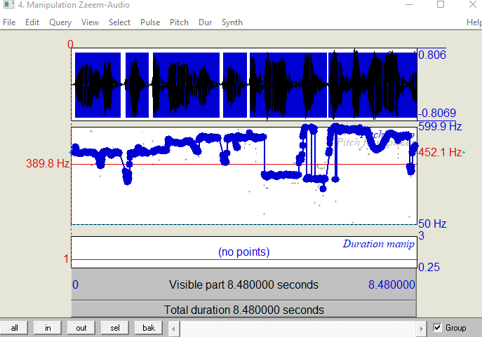

**Cepstrogram:**

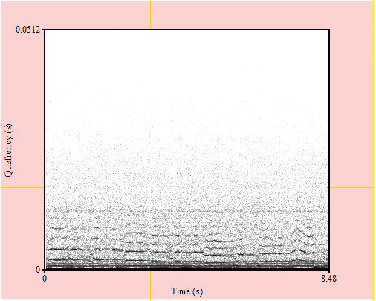

**Harmonicity:**

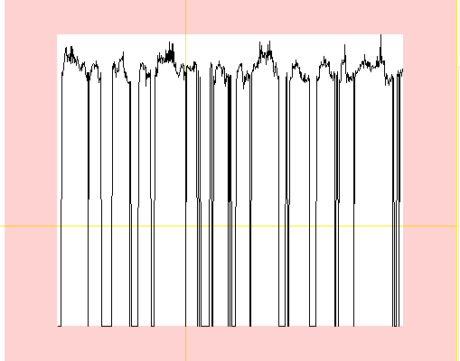

**Voice complete information:**

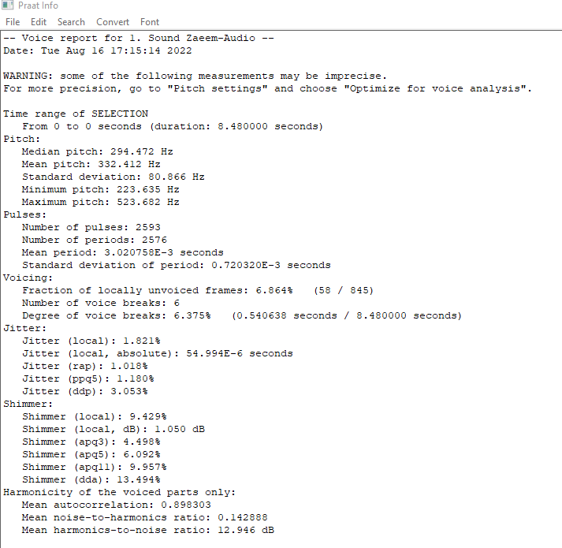

**Auto Correlation:**

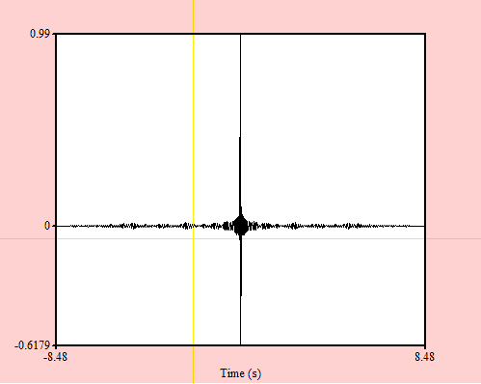

**Spectrogram:**

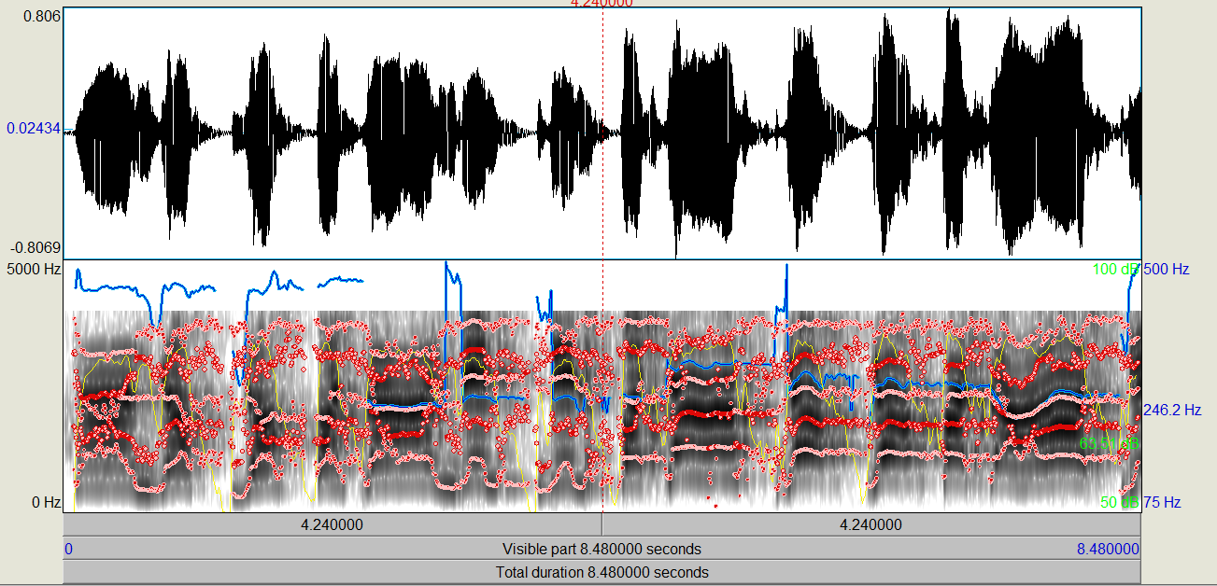

**Outer and inner view port of voice:**

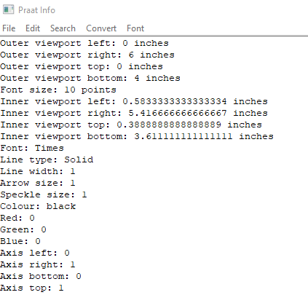

**Analysis on Adult male singing Pakistani Anthem with calmness:**

**Formant of Voice:**

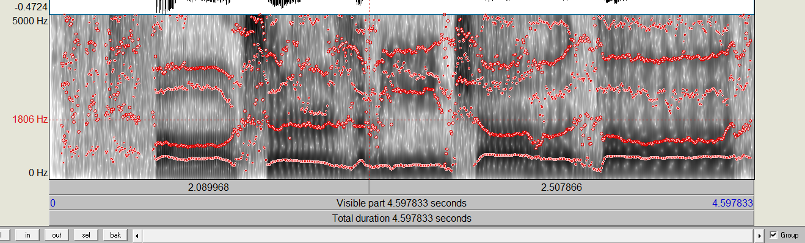

**Intensity of Voice:**

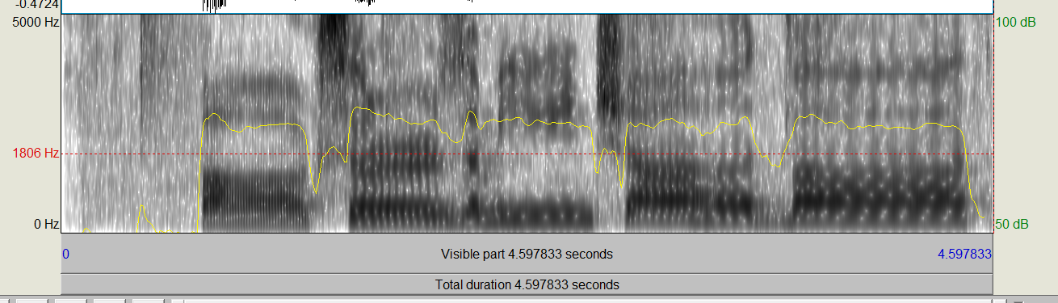

**Pitch of Voice:**

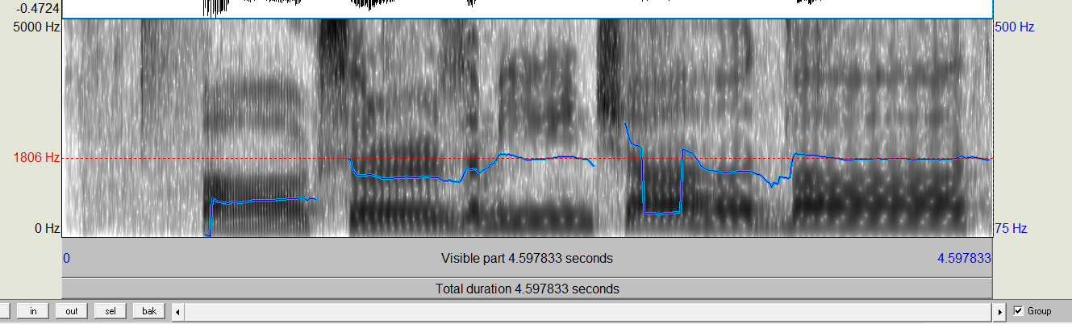

**Power Cepstrum Analysis:**

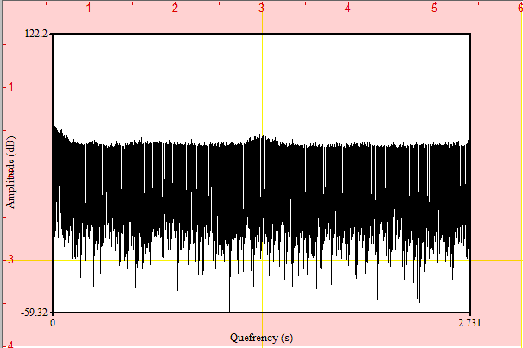

**Excitation of voice:**

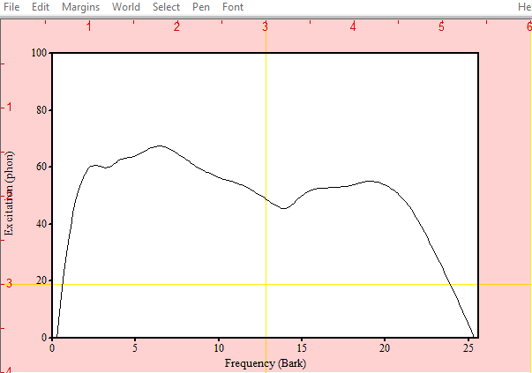

**MFCC of Voice:**

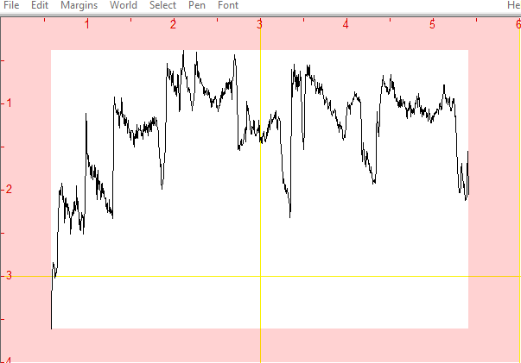

**Spectrum Analysis:**

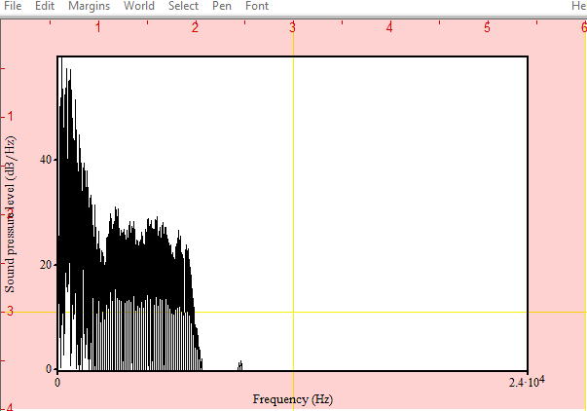

**Spectrum Tier Peak:**

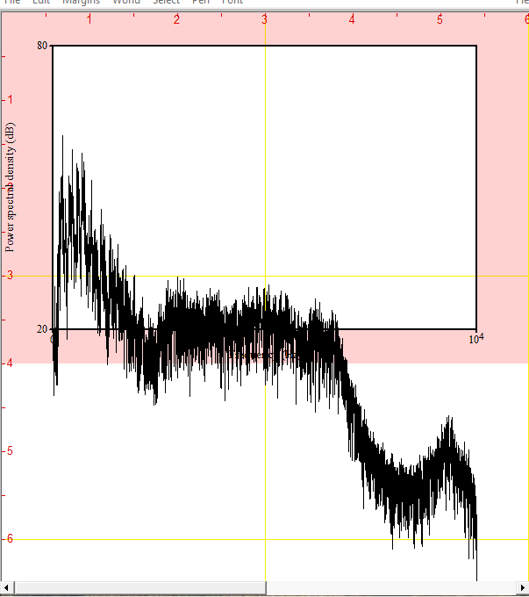

**LPC Gain of Voice:**

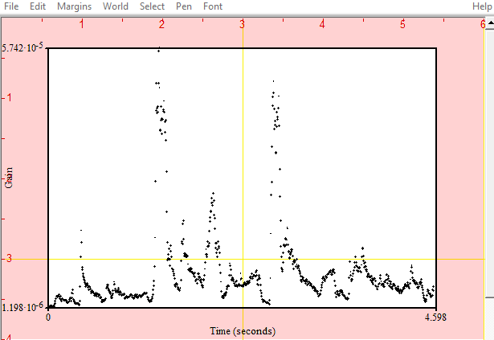

**LPC Poles of Voice:**

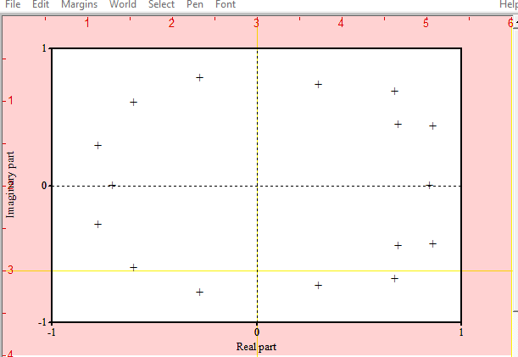

**Cochleagram Analysis of Voice:**

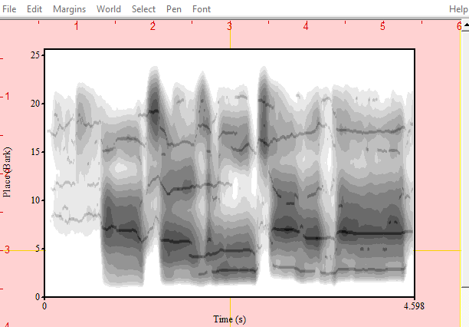

**Manipulation of Voice:**

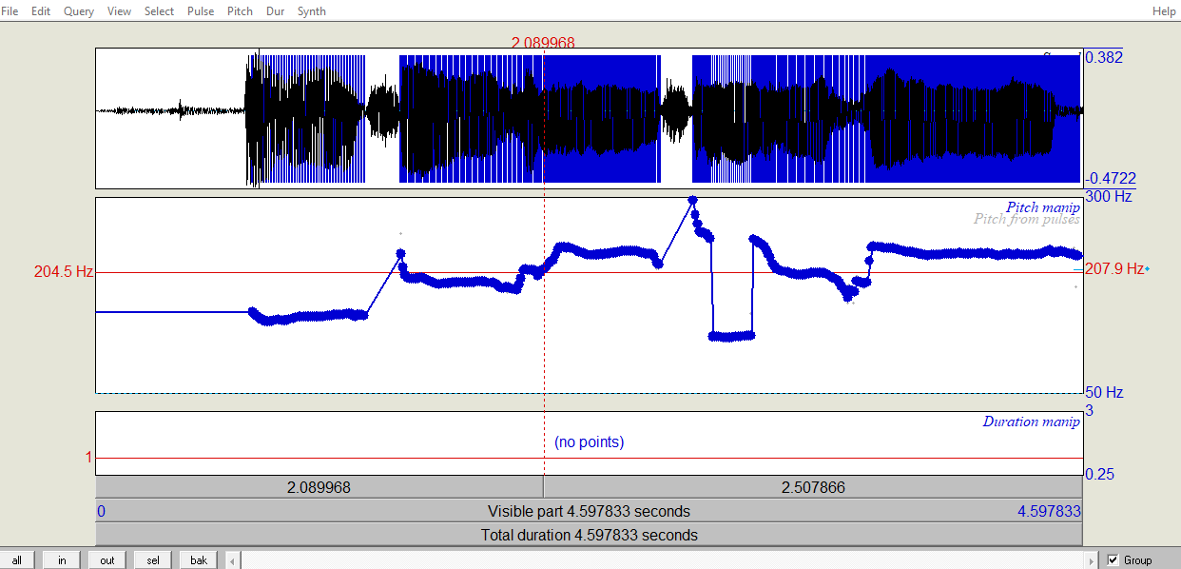

**Cepstrogram:**

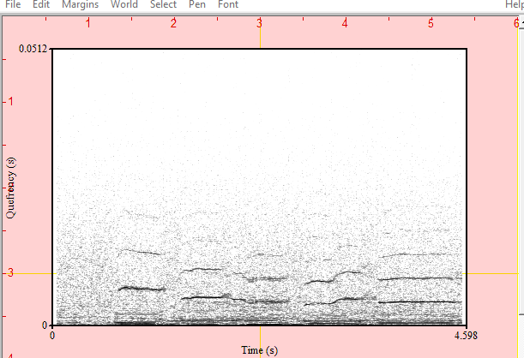

**Harmonicity:**

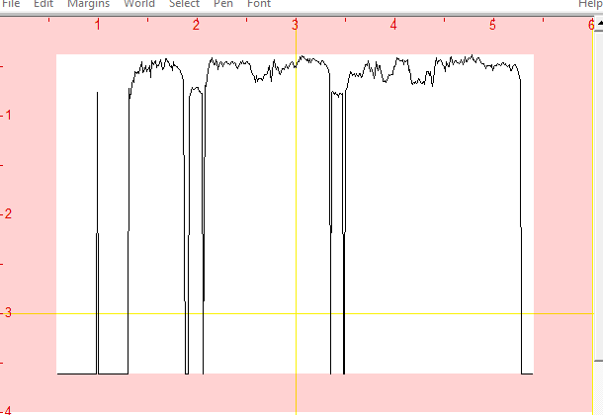

**Voice complete information:**

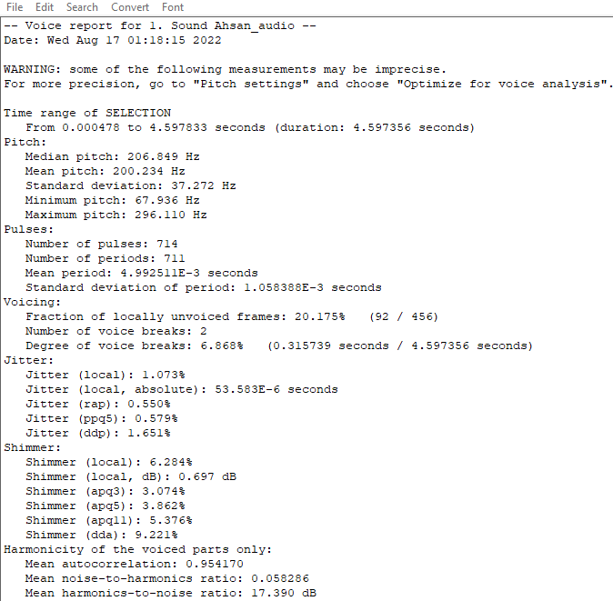

**Auto Correlation:**

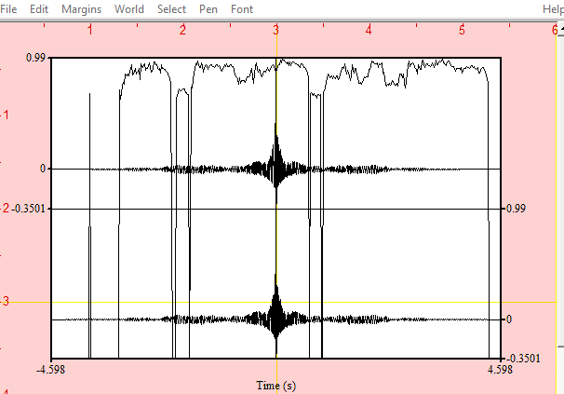

**Spectrogram:**

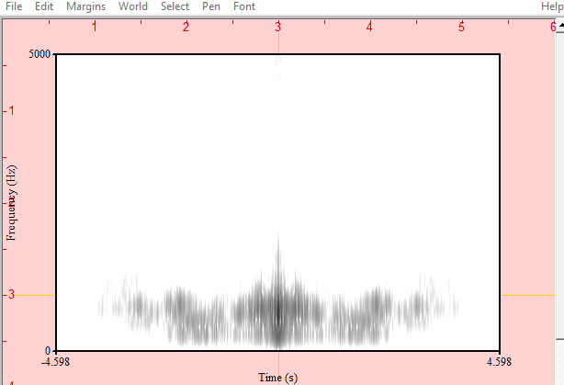

**Outer and inner view port of voice:**

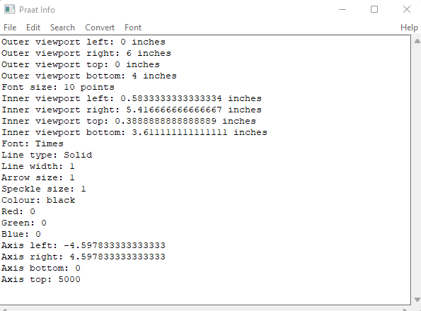

**Analysis on “Women greeting Assalam u Alaikum”:**

**Formant of Voice:**

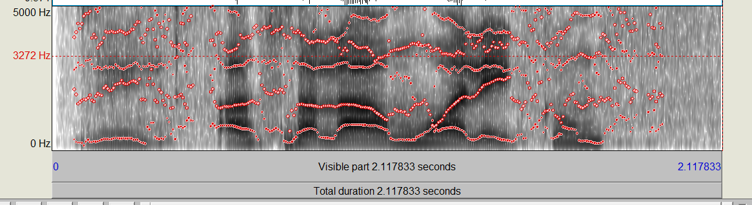

**Intensity of Voice:**

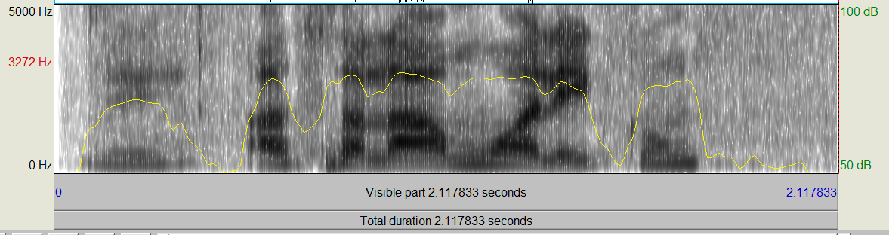

**Pitch of Voice:**

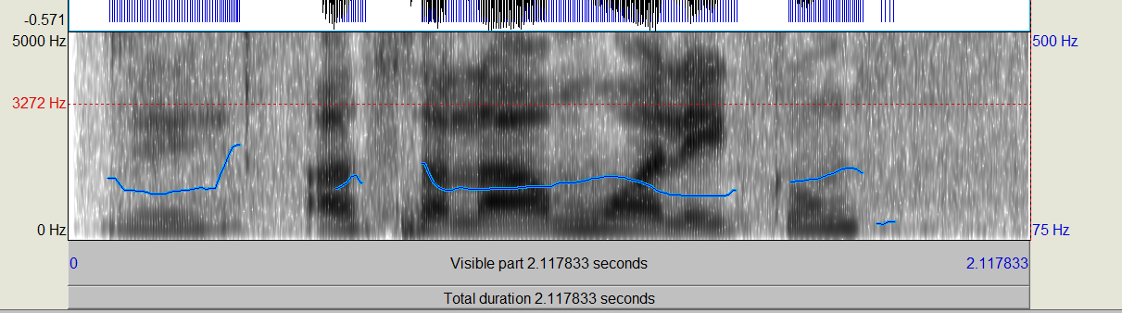

**Power Cepstrum Analysis:**

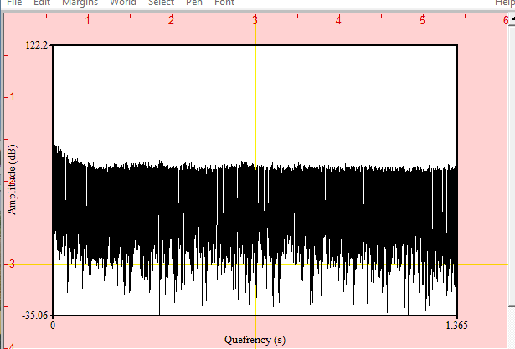

**Excitation of voice:**

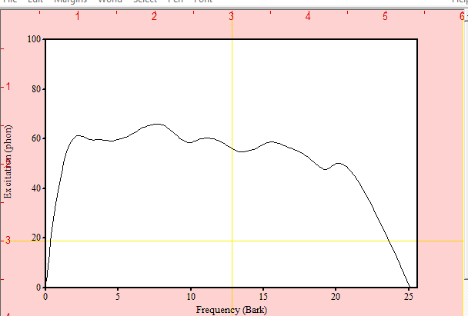

**MFCC of Voice:**

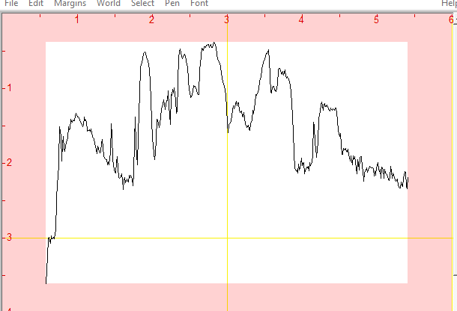

**Spectrum Analysis:**

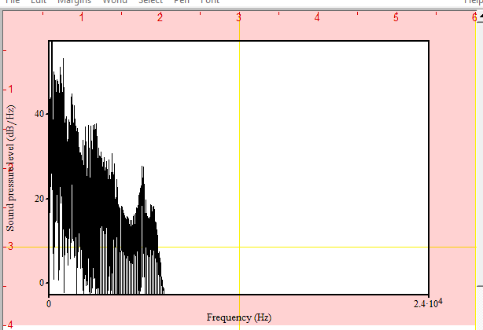

**Spectrum Tier Peak:**

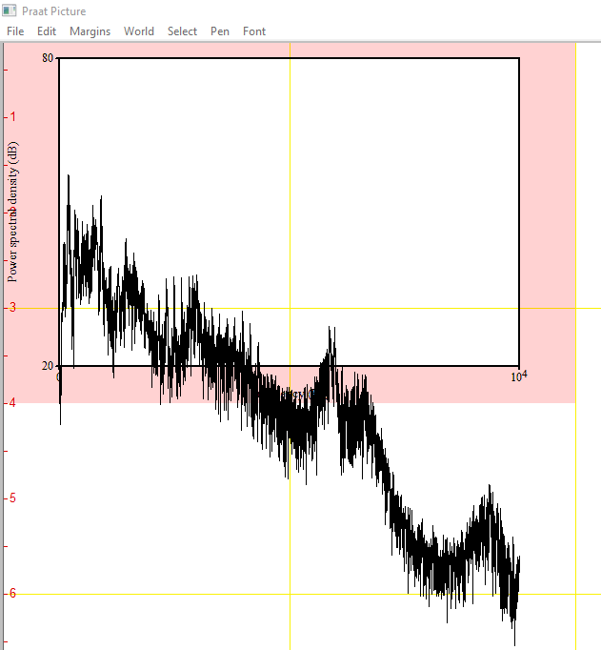

**LPC Gain of Voice:**

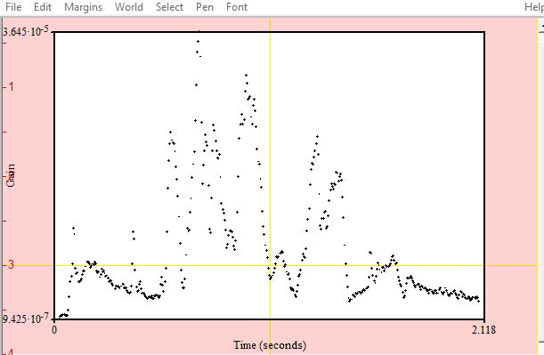

**LPC Poles of Voice:**

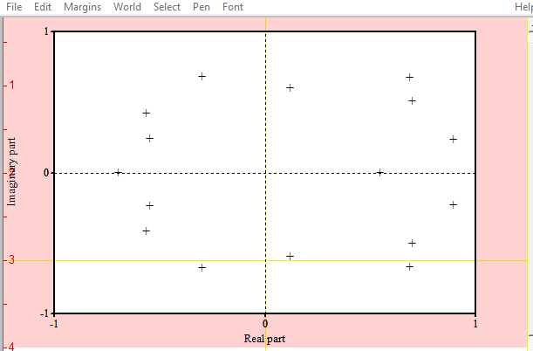

**Cochleagram Analysis of Voice:**

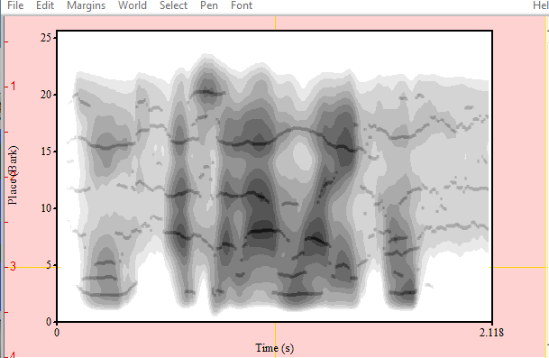

**Manipulation of Voice:**

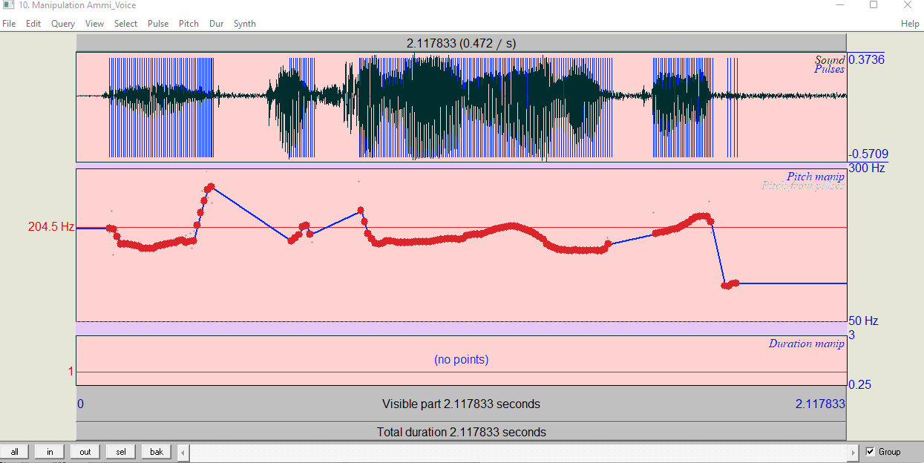

**Cepstrogram:**

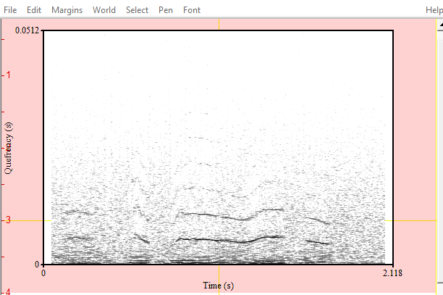

**Harmonicity:**

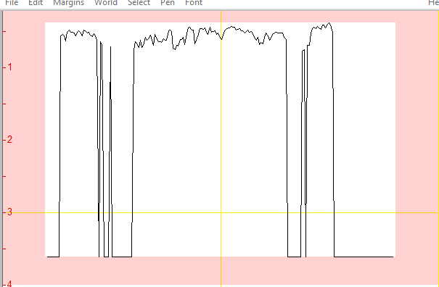

**Voice complete information:**

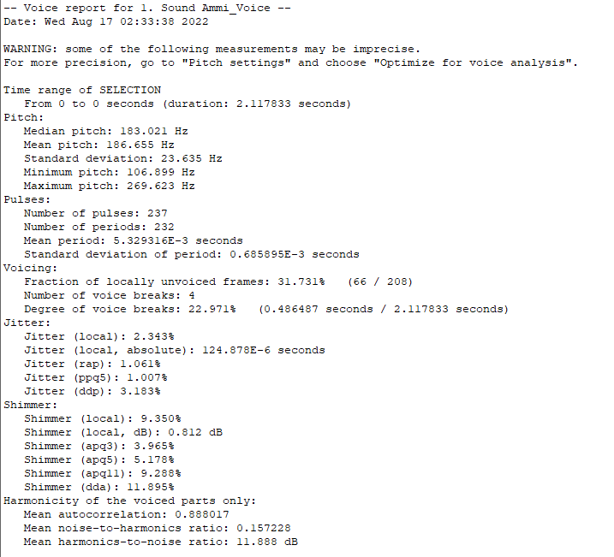

**Auto Correlation:**

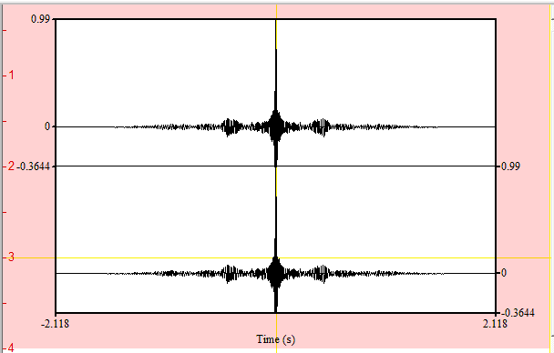

**Spectrogram:**

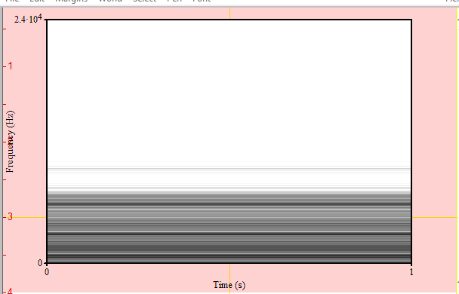

**Outer and inner view port of voice:**

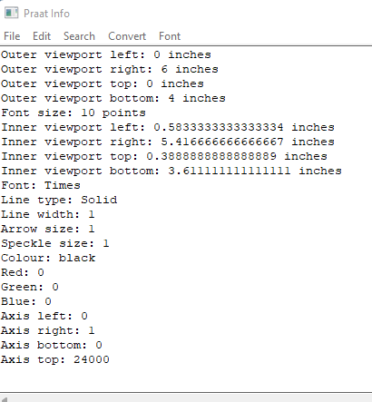

**Analysis on Angry man complaining regarding water and electricity issues:**

**Formant of Voice:**

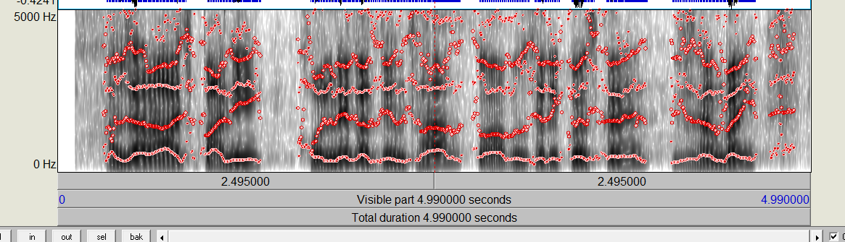

**Intensity of Voice:**

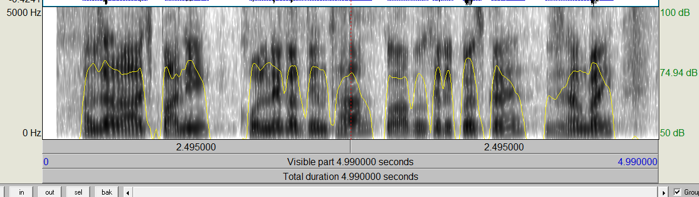

**Pitch of Voice:**

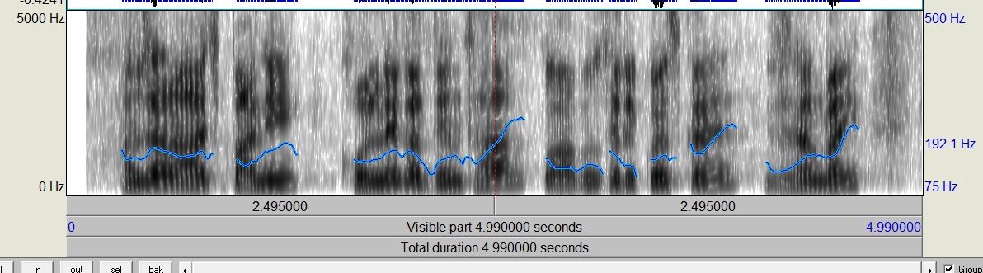

**Power Cepstrum Analysis:**

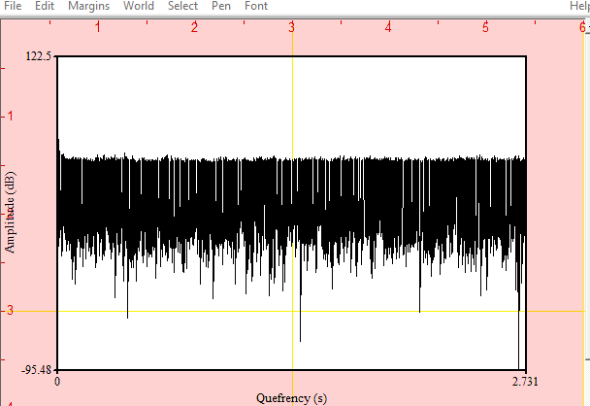

**Excitation of voice:**

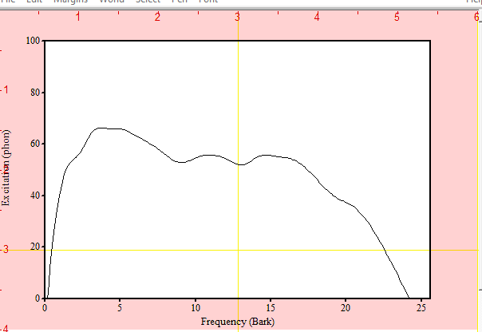

**MFCC of Voice:**

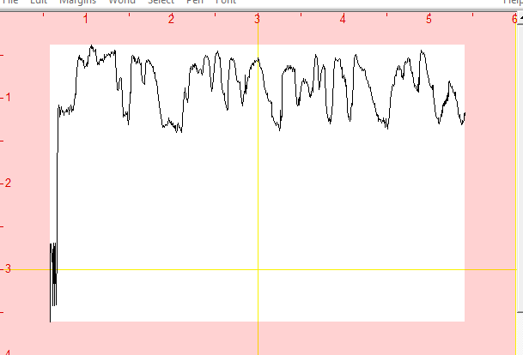

**Spectrum Analysis:**

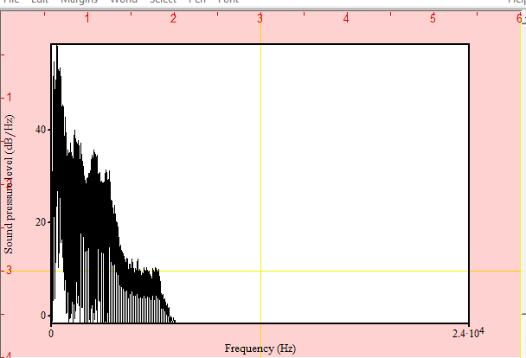

**Spectrum Tier Peak:**

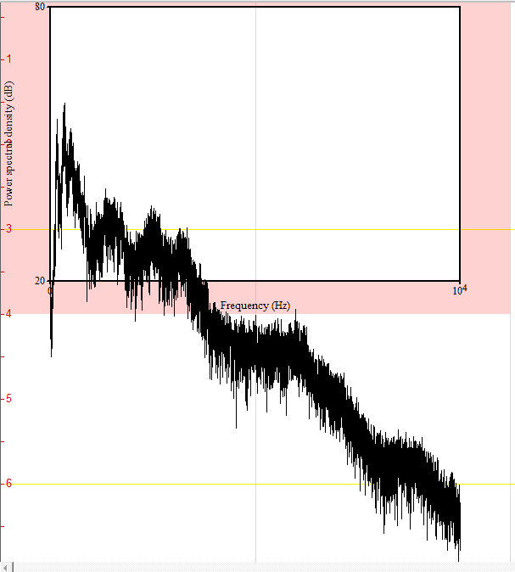

**LPC Gain of Voice:**

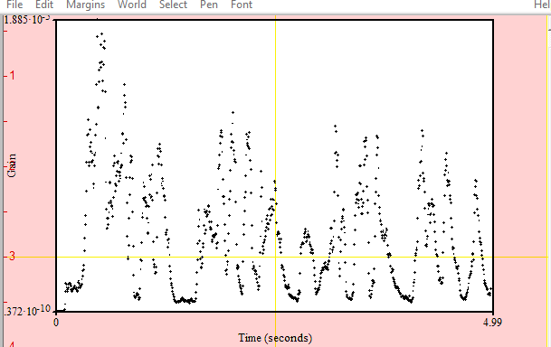

**LPC Poles of Voice:**

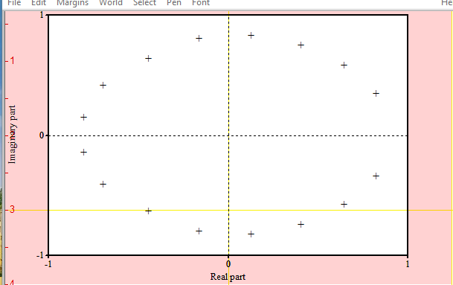

**Cochleagram Analysis of Voice:**

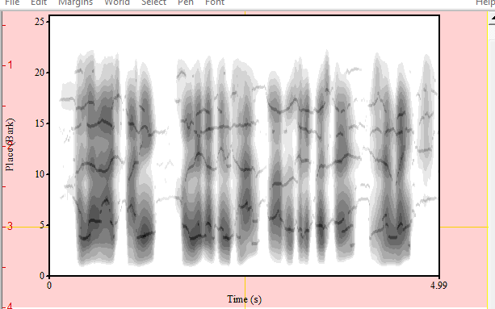

**Manipulation of Voice:**

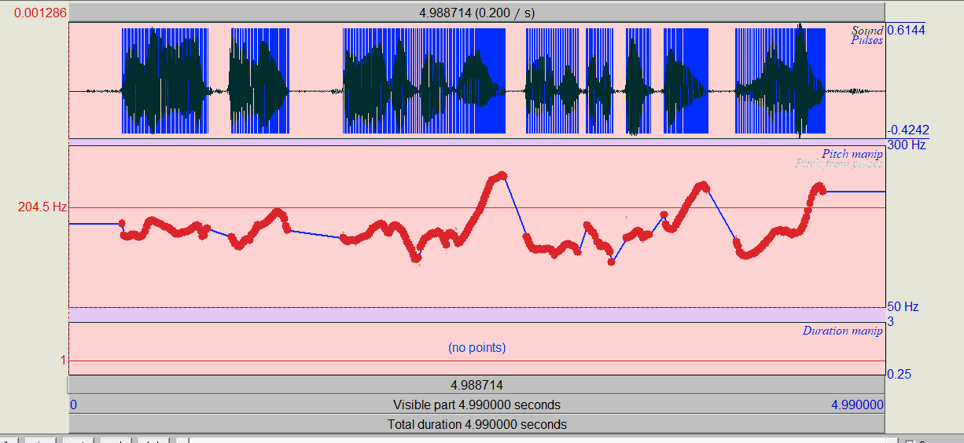

**Cepstrogram:**

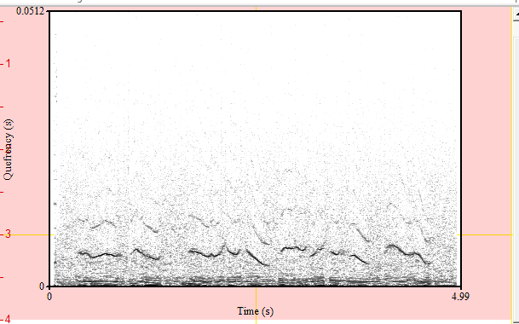

**Harmonicity:**

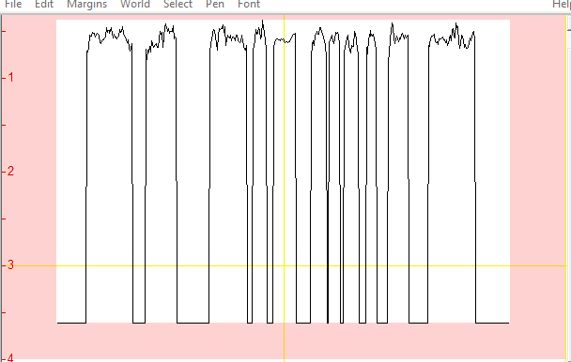

**Voice complete information:**

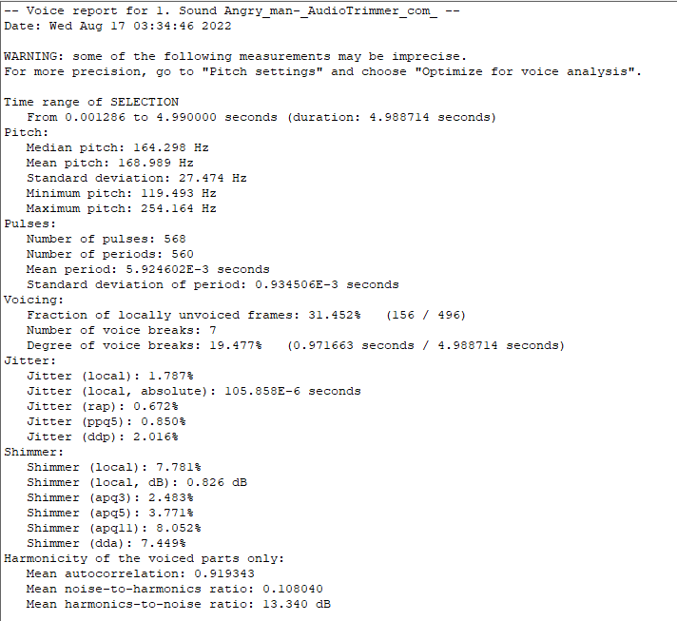

**Auto Correlation:**

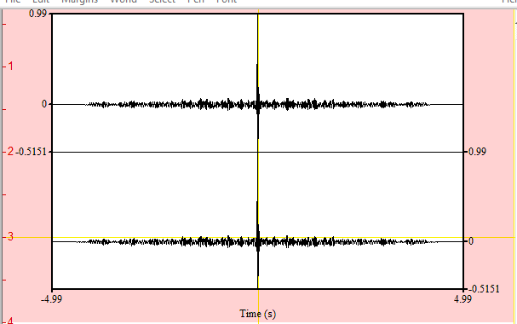

**Spectrogram:**

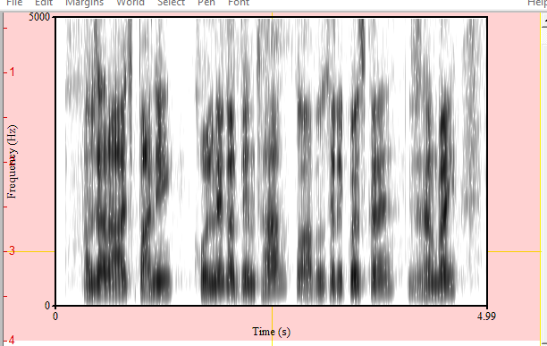

**Outer and inner view port of voice:**

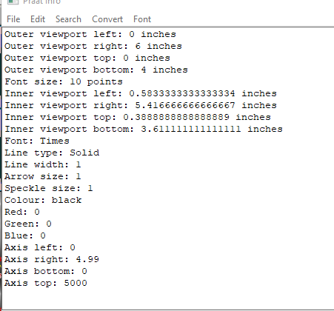

**Comparison between all audience:**

|  |  |  |  |  |
| --- | --- | --- | --- | --- |
| **Analysis** | **5 years old boy singing “Dil Dil Pakistan, Jan Jan Pakistan” with Passion.** | **Adult male singing Pakistani Anthem with calmness.** | **Women greeting “Assalam u Alaikum”.** | **Angry man complaining regarding water and electricity issues** |
| Mean pitch (Hz) | 332.41 | 182.02 | 188.25 | 186.82 |
| Minimum pitch (Hz) | 223.63 | 67.93 | 106.89 | 119.49 |
| Maximum pitch (Hz) | 523.68 | 296.11 | 269.62 | 254.16 |
| Maximum intensity (dB) | 85.84 | 78.67 | 79.89 | 80.83 |
| Minimum intensity (dB) | 46.28 | 38.33 | 41.16 | -20.13 |
| Mean Formant 1 (Hz) | 967.24 | 681.23 | 681.84 | 535.55 |
| Mean Formant 2 (Hz) | 1642.48 | 1642.00 | 1782.28 | 1656.96 |
| Mean Formant 3 (Hz) | 2263.10 | 2867.20 | 2971.48 | 2691.54 |
| Mean Formant 4 (Hz) | 2966.78 | 3833.36 | 3932.78 | 3632.78 |
| Bandwidth 1 (Hz) | 94.50 | 93.28 | 235.70 | 97.21 |
| Bandwidth 2 (Hz) | 691.37 | 197.72 | 387.04 | 65.83 |
| Bandwidth 3 (Hz) | 251.51 | 595.44 | 1084.69 | 193.20 |
| Bandwidth 4 (Hz) | 315.32 | 327.08 | 259.01 | 387.45 |